FB1: Find the volume of the solid generated by rotating the region bounded by the curves $y=e^{x}$, $y=\cos\left(\frac{πx^{2}}{2}\right)$ and $x=1$ about the y-axis.

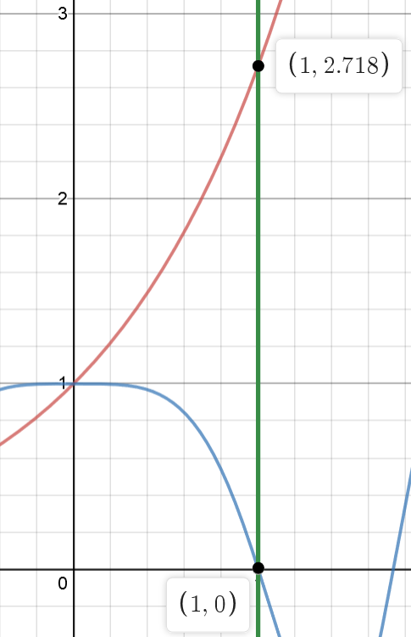

When all three curves are drawn, the graph can be seen in Figure A:

As can be seen from the graph, the region is bounded within the   
points $\left(1,0\right), \left(1,e\right), and \left(0,1\right).$ To find the volume of the solid, let us  
divide the *y* interval of the region into [0,1] and [1,e]. Then the   
volume of the solid becomes a sum of two different volumes of the   
two disks, for which the formula for calculating the areas S is

$$y=e^{x}$$

S $=π{\left(outer radius\right)}^{2}-π{\left(inner radius\right)}^{2}.$

To find the volumes of both disks, the curves must be rearranged   
in terms of *y*, which gives us the following curves:

$$x=1$$

$$y=\cos\left(\frac{πx^{2}}{2}\right)$$

$x=1$,

$x=\ln\left(y\right)$,

$x=\sqrt{\frac{2\arccos{y}}{π}}$,

where x is positive because the region is in the positive side.

Thus, the volume of the lower disk is

Figure A

$$V_{1}=\int_{0}^{1}{π\left(1-\frac{2\arccos{y}}{π}\right)dy} \\ =π\left(\int_{0}^{1}{dy}-2\int_{0}^{1}{\arccos{y}dy}\right) \\ =π\left(1-2\left(\left[1⋅\arccos\left(1\right)-\sqrt{1-1^{2}}\right]-\left[0⋅\arccos\left(0\right)-\sqrt{1-0^{2}}\right]\right)\right) \\ =π-2,$$

and the volume of the upper disk is

$$V_{2}=\int_{1}^{e}{π\left(1-\ln^{2}\left(y\right)\right)}dy \\ =π\left(\int_{1}^{e}{dy}-\int_{1}^{e}{\ln^{2}\left(y\right)dy}\right) \\ =π\left(e-1-\left[e\ln^{2}\left(e\right)-2e\ln\left(e\right)+2e\right]-\left[\ln^{2}\left(1\right)-2\ln\left(1\right)+2\right]\right) \\ =π.$$

Hence, the volume of the whole solid of revolution is the sum of the volumes of both disks:

$$V=V_{1}+V_{2}=2π-2.$$

FB2: Decide whether the set A of positive integers divisible by 17 and B the set of positive integers

divisible by 11 are in bijection.

The set A can be written in the notation $\{a|a=17s,s∈N\}$, and the set B can be written as $\{a|a=11t,t∈N\}$. As can be seen, a function $f:A→B$ can be defined to be

$$f(a)=\frac{11a}{17}.$$

Since *f* has an inverse function

$$f^{-1}(a)=\frac{17a}{11}$$

because it is injective (given by the fact it is a linear function) and surjective (given by the fact that the inverse function is defined for all a $∈$ A), the function *f* is a bijection. Thus, the two sets A and B are in bijection.

FB3: Suppose that $α,β$ are disjoint cycles in the symmetric group $S_{n}$ for $n ≥9$.

a) Let $α$ by a cycle of length 3 and $β$ a cycle of length 9. What is the order of $αβ$. Is the permutation $αβ$ even or odd?

b) Show that for every positive integer *n* we have

$${\left(αβ\right)}^{n}=α^{n}β^{n}.$$

a)

The order of $αβ$ is 9 because it is the least common multiple of 3 and 9. Using the formula

$$sgn\left(g\right)={\left(-1\right)}^{r_{1}-1}{\left(-1\right)}^{r_{2}-1}…{\left(-1\right)}^{r_{k}-1}$$

to find the parity of the permutation, $r_{1}=9$ and $r_{2}=3,$ which gives

$$sgn\left(g\right)={\left(-1\right)}^{8}{\left(-1\right)}^{2}=1$$

and proves that the permutation is even.

b)

By the definition of exponentiating permutations,

$${\left(αβ\right)}^{n}=\underset{n}{\underbrace{\left(αβ\right)⋅\left(αβ\right)⋅…⋅\left(αβ\right)}} \\ =\underset{n}{\underbrace{α⋅α⋅…⋅α}}⋅\underset{n}{\underbrace{β⋅β⋅…β}} \\ =α^{n}β^{n}.$$

This rearrangement can be done because $α$ and $β$ are disjoint, which means that they commute.